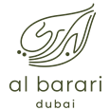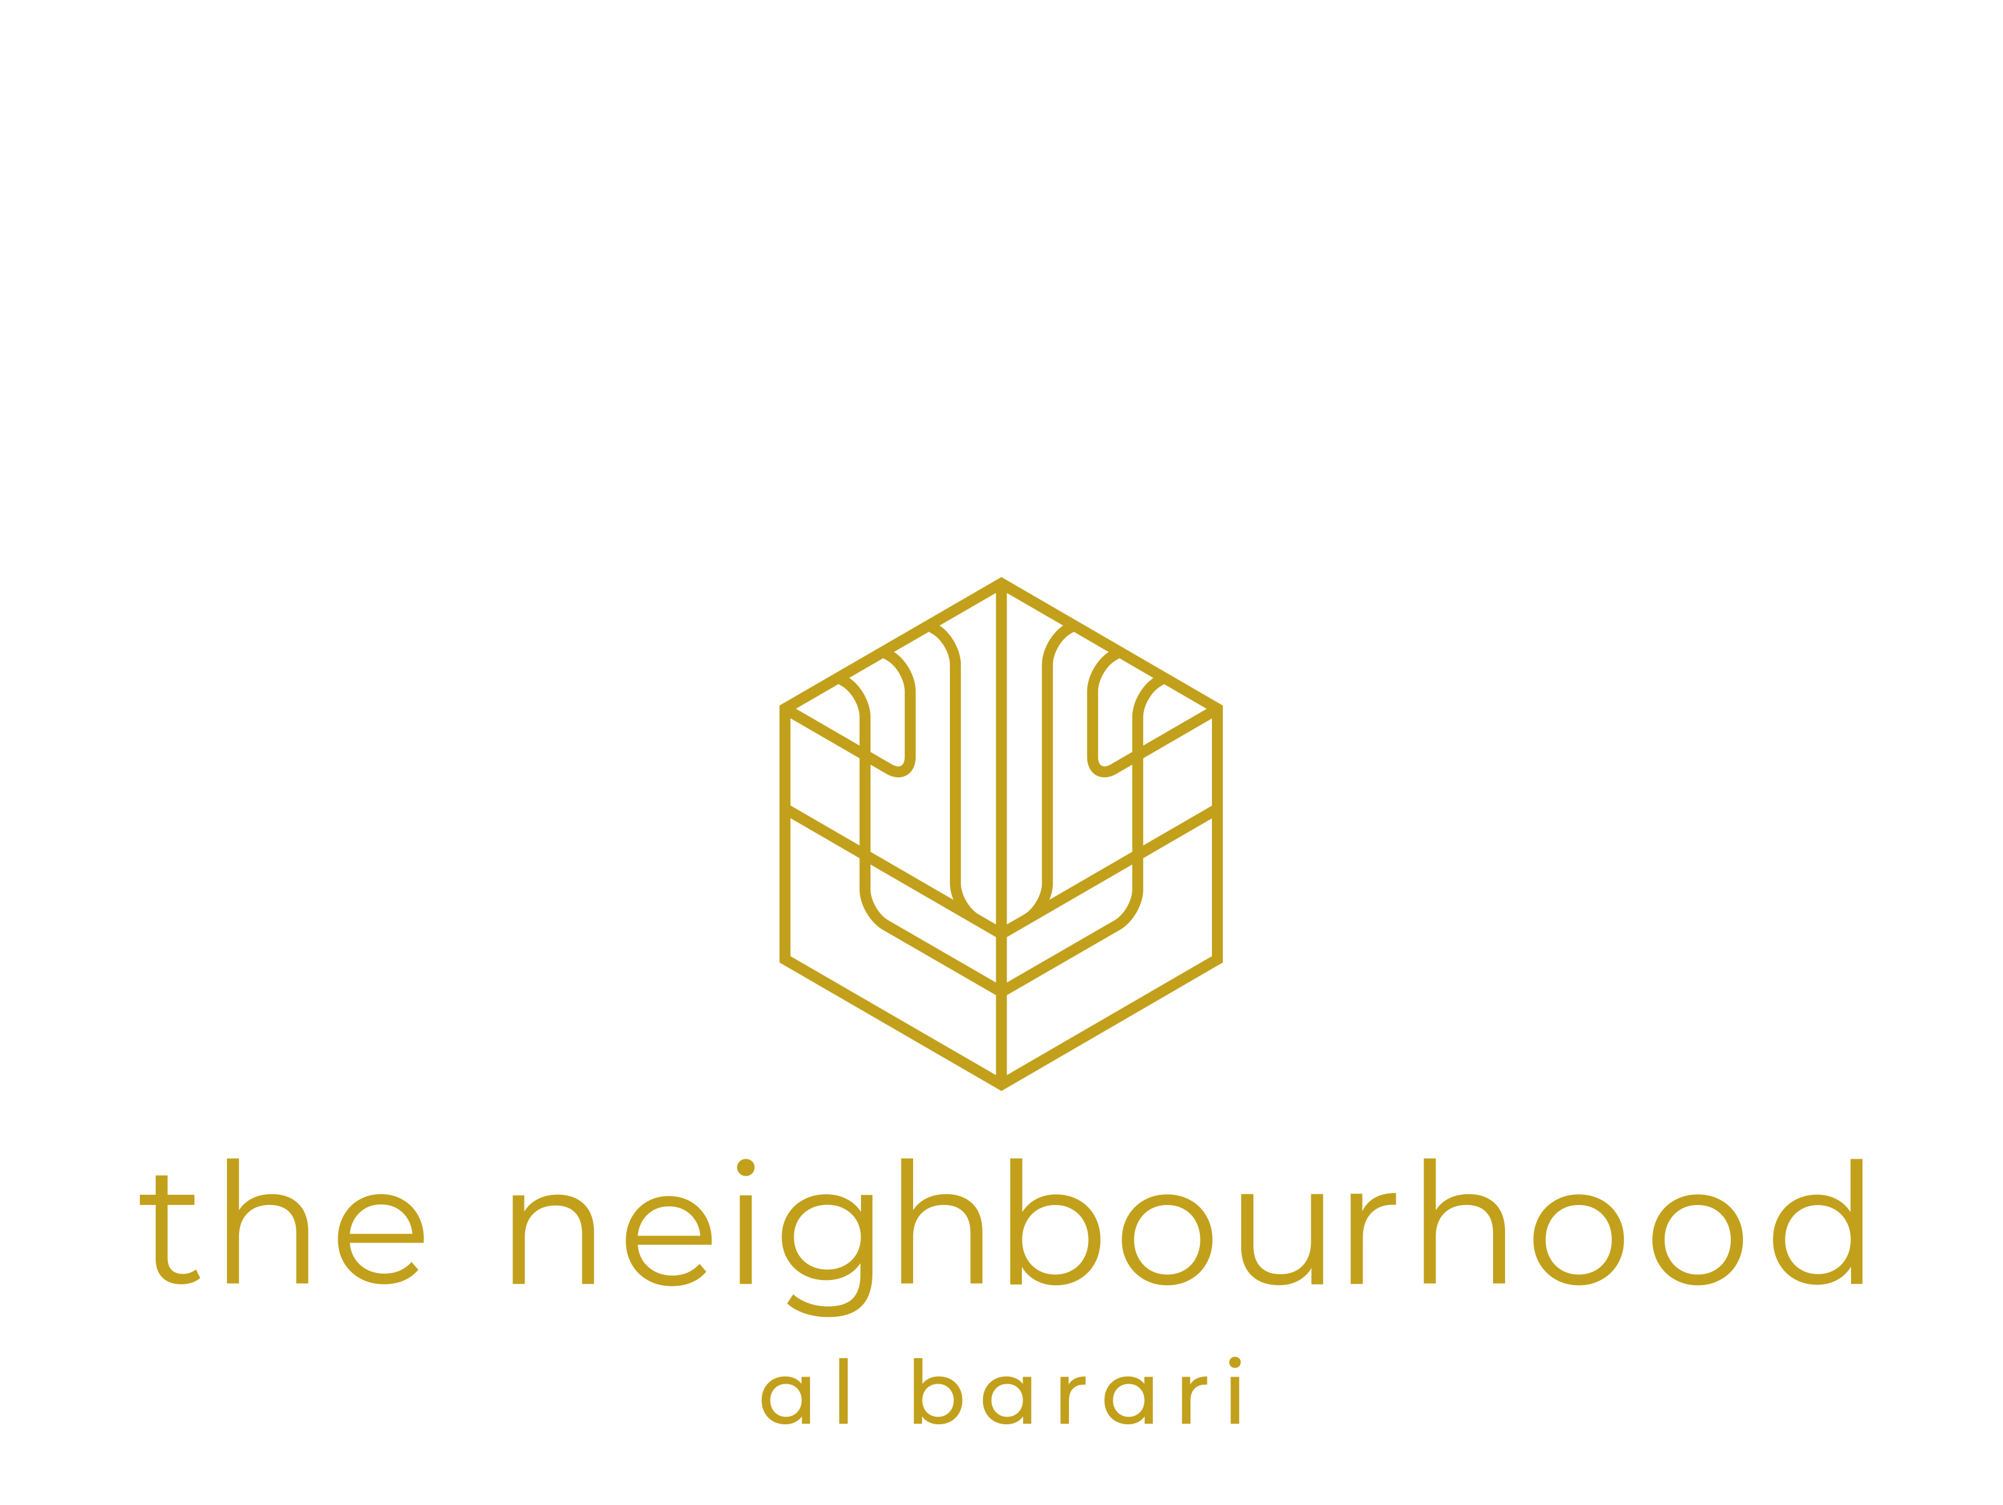

The Neighbourhood, Al Barari

Fact Sheet

Al Barari住宅小区

项目简报

Developer Abwab Real Estate

开发商 Abwab 房地产开发公司

Project 182 apartments

4 buildings

2 building types

项目 182 套公寓

4 幢建筑

2 种建筑类型

Apartment Types

公寓类型

Studio 31

1 Bedroom 98

2 Bedroom 53

单身公寓 31

1室 98

2室 53

Unit (sq ft) Terrace (sq ft)
单位（平方英尺）露台（平方英尺）

Studio 433 - 591 49 - 52
1 Bedroom 650 - 913 24 - 817
2 Bedroom 1,051 - 1,317 122 – 606
单身公寓 433-591 49-52
1室 650-913 24-817
2室 1,051-1,317 122- 606

The Neighbourhood features 4 low-rise and low-density buildings surrounded by a dense forest creating secluded natural havens.

“住宅小区”项目有4栋低层、低密度建筑组成，周围环绕着茂密的森林，形成了隐蔽的天然庇护所。

Set within Al Barari’s lush, green landscape, The Neighbourhood is a bespoke living space that effortlessly blends together first-class residences, boutique hospitality, leisure, and wellness amenities. A living environment centred on wellness for the city’s dynamic leaders who seek a modern lifestyle that’s both mindful and in tune with their own natural rhythm. A home like no other for ambitious and successful leaders who enjoy a dynamic social and professional life in the metropolis during working hours and seek the sanctuary of a modern home surrounded by nature and balance.
在Al Barari郁郁葱葱的绿色景观中，住宅小区是一处将一流的住宅、精品酒店、休闲和健康设施轻松融合的定制化生活空间。这是一个以健康为中心的生活环境，专为那些寻求现代生活方式的城市活力领导者们而打造，这种生活方式既注重健康理念又符合居住者自己的自然节奏。一个与众不同的住宅项目，能够满足雄心勃勃和功成名就人士的各种需求，既能让他们在忙碌的工作期间享受大都会充满活力的社交和职业生活，又能在闲暇之时使他们觅得一处被自然和平衡包围着的现代家庭的圣殿。

Amenities These buidings will share an underground parking (one parking spot per apartment) and swimming pools for adults and kids.

配套设施 这些建筑将共享一个地下停车场 (每套公寓一个停车位) 和成人和儿童游泳池。

Residents will also have access to Seventh Heaven retail offerings and dining venues.

居民还可以使用“第七天堂”项目中的各种设施，包括零售商店和餐饮场所。

Al Barari features as well Body Language health club, which includes a gym, infinity-edge swimming pool, two tennis courts, and a studio dedicated to group classes; The Farm restaurant, Heart & Soul spa, Nature Escapes, and Starlight Movie Nights.

Al Barari 还拥有一个名为“肢体语言”，包括健身房、无限边缘游泳池、两个网球场和一个专供分组上课工作室的健身俱乐部，“农场”餐厅，“心灵”水疗中心，“亲近大自然”郊游和“星光下的电影之夜”。

Design The materials are natural, robust, and durable but also have character and neutrality that enables each individual the opportunity to bring a touch of their own style and colour preference to the space. The layout is highly practical and versatile offering ample space for storage. The kitchen is the social heart of the apartment, featuring an open and contemporary plan with the joinery and kitchen island designed like pieces of furniture.

建筑设计 建筑材料不仅天然淳朴、坚固耐用，而且还具有个性和中立性，使每个人都有机会在空间设计上融入一些他们自己喜欢的风格和色彩。公寓布局讲究安全实用、功能多样，拥有充足的储存空间。厨房是公寓中家庭成员间的交流中心，设计开放、现代，细木工制品和岛式厨房设计巧妙，如一件件精美的家具。

Designed to create harmony and enhance healthy habits. Here, residents feel fully immersed in a wellness centred lifestyle which promotes a calm, relaxed, and connected living environment.

该项目旨在营造一种和谐的氛围和增进人们的健康习惯。在这里，居民能够完全沉浸于以健康为中心的生活方式中，由此创立一种平静放松、和谐共生的生活环境。

From the ground level to the second floor, buyers can opt for residences that seamlessly blend within the green surroundings, while upper floors offer views of Dubai skyline and Burj Khalifa.

从一楼到三楼，买家可以选择完美融入周边绿色环境中的高档公寓，而高层物业则可欣赏迪拜天际线和哈利法塔的美景。

Sustainability Natural light
Smart control irrigation
Waste management and recycling
Water treatment
可持续设计 自然采光
智能控制灌溉
废物管理和循环利用
水处理

Location Accessible from Sheikh Mohammed Bin Zayed Road (E311), The Neighbourhood is located in Al Barari estate and occupies the land adjacent to the Nature Reserve. Al Barari is located 15-20 minutes away from Downtown and Burj Khalifa, Palm Jumeirah, and Dubai airport.

地理位置 “住宅小区”位于Al Barari社区，占据着“自然保护区”旁的土地，从谢赫穆罕默德本扎耶德路（E311号公路）可轻松抵达。

Schools near Al Barari:

Al Barari附近学校：

- Jumeirah English Speaking School

- Repton School Dubai

- American School of Dubai

- Emirates International School

- Dubai international Academy

-朱美拉英语学校（JESS）

-迪拜雷普顿学校

-迪拜美国学校

-阿联酋国际学校

-迪拜国际学院

Al Barari First envisioned by Emirati businessman Zaal Mohamed Zaal in 2005, Al Barari, literally meaning wilderness in Arabic, was designed to be a true desert oasis. Sixty percent of the development is made up of green space that envelopes 189 Al Barari residences and bespoke luxury villas of The Reserve. Ashjar, a collection of 120 elegant apartments available in three distinctive categories, Seventh Heaven, an exceptional collection of 157 homes including exclusive duplexes, penthouses, villa size apartments and garden homes, The Neighbourhood, 182 studios, 1 and 2 bedroom apartments, and The Nest, a collection of 55 family-style villas, are currently under development. The estate features its own health club, Body Language and signature restaurant, The Farm as well as Heart & Soul spa, nature Escapes, and Starlight Movie Nights. A total of six themed gardens with over 425,000 sq ft of naturally landscaped lakes, freshwater streams, cascades and waterways make Al Barari the lowest density development in the UAE and more akin to a botanical garden than a residential community. Garden maintenance and landscaping services are provided onsite by Al Barari’s green arm, Green Works.
Al Barari简介 Al Barari最初是由阿联酋商人扎尔·穆罕默德·扎尔先生于2005年提出的设想，该词在阿拉伯语中的字面意思为“原野”，被赋予了成就真正沙漠绿洲的使命。在这块开发土地上，60%是绿地，包围着189栋Al Barari住宅及多幢The Reserve定制豪华别墅。Ashjar,一组呈现3种不同建筑风格的120套高档公寓； “第七天堂”，一系列出色的包含157套包括专属复式公寓、顶层公寓、别墅公寓和花园住宅的高档住宅；包含182套单身公寓、1、2室公寓的“住宅小区”项目；以及拥有55套家庭别墅的The Nest,目前全部都在开发建设中。该社区设有专属健身中心“肢体语言”，特色餐厅“农场”以及“心灵”水疗中心、“亲近大自然”郊游和“星光下的电影之夜”。六大主题园林、超过42.5万平方英尺的自然景观湖、淡水溪涧、瀑布以及水道将Al Barari打造成了阿联酋地产项目密度最低的开发项目，与其说它是一个住宅小区，还不如说它是一个植物园。这里的园林养护和景观美化服务则由 Al Barari的合作伙伴“绿色工程”现场提供。

